# 

# 

# **Decision Analytics For Business and Policy Final Project**

# Maximizing Bank Profit Success: An Optimized Marketing Strategy

**Team 12**

**Abigail (Tianai) Zhang (tianaiz@andrew.cmu.edu, tianaiz)**

**Jingchen Fu (jingchef@andrew.cmu.edu, jingchef)**

**Mandi Liu (mandil@andrew.cmu.edu, mandil)**

**Enze Zhao (enzez@andrew.cmu.edu, enzez)**

**Prof. Peter Zhang**

**Carnegie Mellon University**

**Heinz College**

**December 8, 2023**

Contribution:

Abigail: objective function, optimization model & proposal

Enze: objective function & optimization model & slides

Jingchen: proposal & OptGuide questions generation & slides

Mandi: proposal & OptGuide scripts & slides

# Executive summary

This report presents the outcomes of a project by our team aimed at refining the marketing strategies of a Portuguese bank for its term deposit products. Employing a dataset with client demographic and past campaign information, the team formulated three strategic models. The initial model proved profitable in a limited-scale trial, while expanded and diversity-focused strategies forecasted significant net gains of $11,572 and $11,322, respectively. Critical insights revealed the role of factors such as client education and age in enhancing subscription success, showcasing the effectiveness of the bank's method in selecting clients. Additionally, the project involved sensitivity analysis to assess the resilience of these strategies under different scenarios.

The endeavor encountered hurdles with the inconsistent outputs from OptiGuide, highlighting the necessity for clear guidelines and meticulous analysis of data. Ultimately, the project exemplified the efficacy of data-centric tactics in refining marketing operations within the banking sector. This method successfully merged profit generation with the incorporation of inclusivity and diversity in client outreach, boosting the efficiency of marketing activities and aligning with the bank's wider economic and societal goals.

# 

# Analytical Models and Data

## Introduction & Background Information

**Problem Statement**

Our dataset typically originates from a Portuguese banking institution, often used to explore data-driven marketing strategies. The primary purpose of collecting this data is to analyze and improve the effectiveness of direct marketing campaigns focused on promoting term deposits among the bank's clients. It contains information about bank clients and the bank's marketing efforts. Key features include client demographics information such as age, job, marital status, education, etc. Thus, our team came up with the main question that is ​​How can our team help this bank strategically allocate marketing resources to achieve the highest possible net profit from successful term deposit subscriptions while minimizing costs through phone calls.

**Objective Function**

Maximize the net benefit of a marketing campaign from successful subscriptions and minimize the costs incurred through the phone calls.

Max net profit = $Σi (P*pi*Xi) - Σi (C*Xi)$

**Parameters**

*pi*: This represents the predicted probability of the client *subscribing* to a term deposit.

*C*: This is the cost associated with reaching out to client *i*.

P: This represents the profit per subscription

**Decision Variable**

*Xi:* A binary decision variable indicating whether to target client *i* in the marketing campaign

**Pi calculation**

After we completed all the preprocessing of our team’s dataset, we split the data into training and testing sets, and scale the features, and then train the logistic regression model. The model makes predictions on the scaled test set. It also predicts probabilities of the positive class for the training set, which is the predicted probabilities of subscription.

## Optimization Model

**Model #1**

As part of the bank's strategic marketing efforts, we conducted a pilot trial to test the profitability of a champion model under resource constraints. Our objective was to determine the efficacy of our campaign with a limited number of calls.

Campaign Constraints and Results:

* Maximum Number of Calls: 1000 calls (Constraint)
* Number of Clients Selected: 55
* Total Expected Subscriptions: 31
* Net Profit: $200

The trial campaign was designed to operate within the bounds of constrained resources, specifically limiting the campaign to a maximum of 1000 phone calls. With this limitation, we targeted 55 clients, which resulted in 31 new subscriptions. The net profit from this pilot stands at $200. The data indicates a positive return, with the net profit suggesting that the champion model is capable of generating revenue even when resources are carefully allocated. The conversion rate from calls to subscriptions is approximately 56%, which suggests a high level of efficiency in our client selection process.

**Model #2**

Building upon the success of the initial pilot, we are set to launch a full-scale marketing campaign utilizing the champion model, aiming to maximize subscriptions. Our optimization model has confirmed the profitability and scalability of the strategy. We are leveraging the entire workforce to execute the campaign to achieve the highest possible number of subscriptions.

Campaign Constraints and Results:

* Minimum Expected Subscriptions: 1000 (Constraint)
* Number of Clients Selected: 5444
* Total Expected Subscriptions: 2246
* Net Profit: $11,572

The optimization model predicts that engaging our full employee roster in the campaign will significantly exceed our minimum subscription target, achieving over double the expected number. With a substantial net profit forecasted, the model validates the decision to escalate the campaign to a larger scale.

Following the deployment of the second model, we conducted a meticulous analysis of the client group that had been chosen. Our attention was particularly drawn to the attributes that were assigned a greater weight by the logistic regression model, signifying their importance in predicting successful outcomes. Upon further examination, we pinpointed education and age as the two critical features warranting focused consideration. A comparison revealed that the age distribution within the selected client cohort closely mirrors that of the original dataset, suggesting that our selection process is effectively capturing the broader age-related trends present in our overall market (refer to table 1).

The distribution of education levels presents a more intriguing picture. Compared to the original dataset, the client group selected by the second model includes a smaller proportion of individuals with primary education — less than 10% — highlighting an area for increased diversification (refer to table 2).

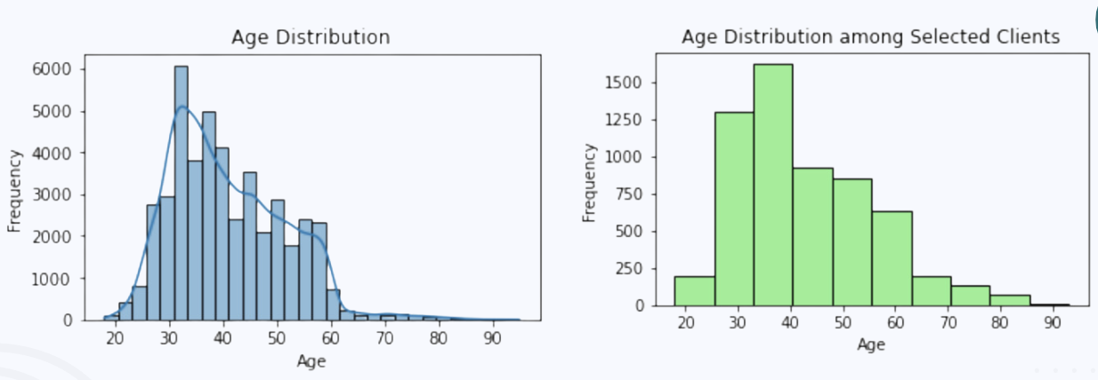

Table 1. Age Distribution Comparison Between Original Database and Model 2.

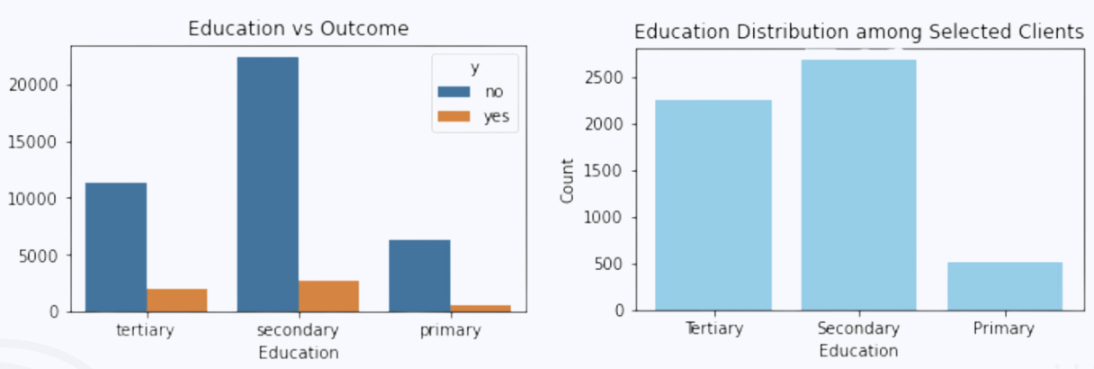

Table 2. Education Distribution Comparison Between Original Database and Model 2.

**Model #3**

Thus, the third optimization model was crafted to enhance the diversity within our client base, with a particular focus on reaching out to individuals with primary education. This report details the outcomes and strategic decisions of this diversity-centric campaign.

Campaign Constraints and Results:

* Minimum number of primary educated clients = 1000
* Number of Clients Selected: 5934
* Total Expected Subscriptions: 2319
* Net Profit: $11,322

The campaign's strategic shift towards including clients with primary education has resulted in a substantial client engagement, with 5934 clients selected and an impressive subscription conversion. Initiative has not only expanded the diversity of our client base but also yielded a notable net profit, indicating that inclusivity aligns with our financial objectives (refer to table 3).

Table 3. Education Distribution Comparison Between Model 2 and Model 3.

# OptiGuide Interaction

We designed 10 questions to make a sensitivity analysis. Our main focus was on Model 1 and Model 3. Model 2 was skipped because Model 3 is an improved model with a diversity in education level, compared to Model 2.

## Part 1: The Constraints of Model 1

In Model 1, we assumed a scenario with only limited sales people making calls. Our aim was to determine the upper limits for both the number of calls made and the call duration within a day, in order to better arrange the workload of sales people. Questions 1 to 3 are related to Model 1.

Initially, we tested by reducing the max_calls by 10% and observed no change in the optimal value. Upon increasing the max_duration by 10%, we noticed a 6% increase in the optimal value.

**Question 1.What if we decrease the max_calls by 10%?"**

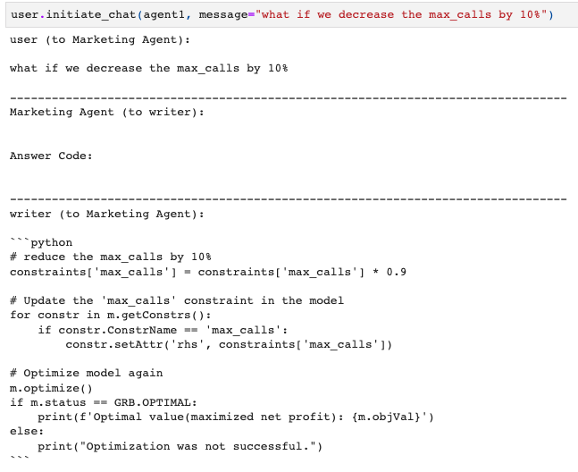

--- HUMAN READABLE ANSWER ---

--------------------------------------------------------------------------------

writer (to Marketing Agent):

After decreasing the maximum number of calls by 10%, the new optimized solution yielded the same objective value (net profit): 209.96712231261685. This suggests that originally, we were not using the full call capacity in the first place, and thus reducing the maximum call volume did not impact the total net profit. We can infer that there might be other constraints limiting our solution, or our current combination of calls already brings in the maximum profit.

--------------------------------------------------------------------------------

**Question 2.What if we increase max_duration by 10%?**

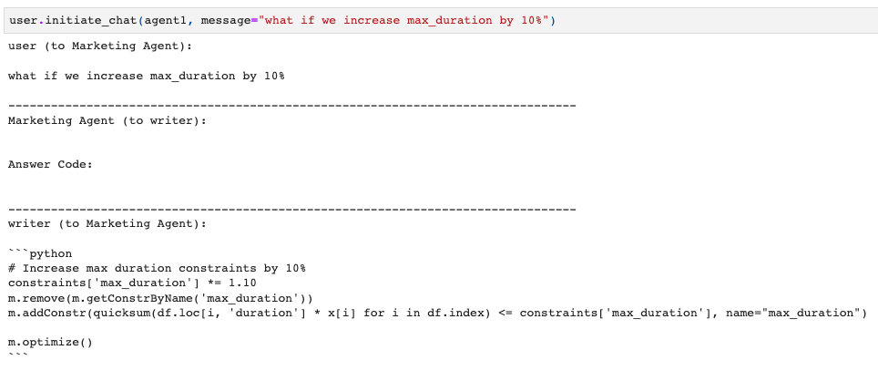

--- HUMAN READABLE ANSWER ---

--------------------------------------------------------------------------------

writer (to Marketing Agent):

Sure, increasing the maximum call duration by 10% leads to a larger feasible region for the optimization problem. As a direct result, we can see that the optimized objective value (the estimated profit of the marketing campaign) increased from the original 209.97 to the new value of 223.2. This corresponds to roughly a 6.3% increase in estimated profit.

--------------------------------------------------------------------------------

Further analysis was done within a range of 500 to 1500 calls and a call duration of 5000 to 15000 seconds. The most efficient parameters were identified to be 500 calls and 14000 seconds. This adjustment enhanced the optimal value by about 24%.

**Question 3.What is the best combination of max_calls and max_duration, for max_calls in range of (500,1500) and max_durations in range of (5000,15000)?**

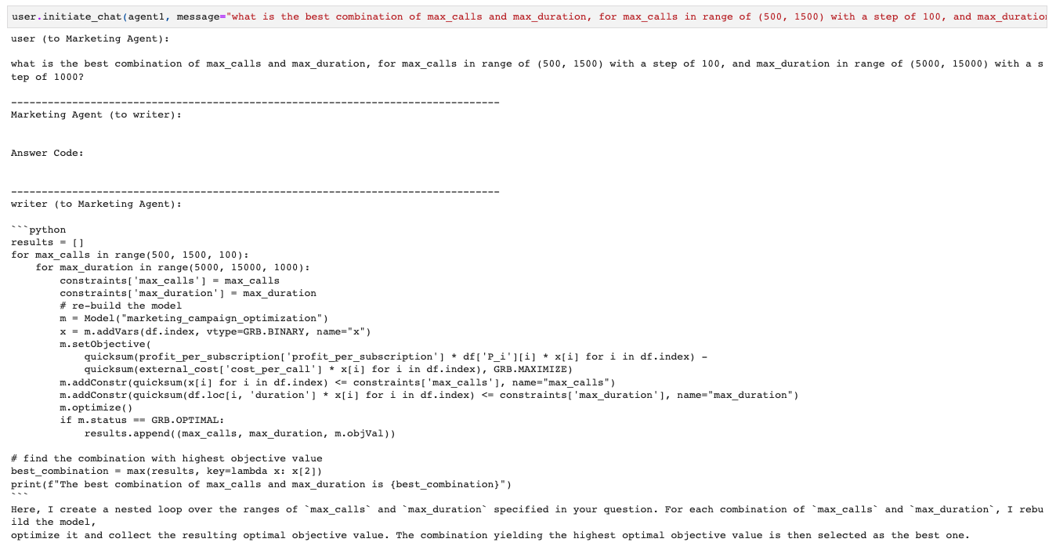

--- HUMAN READABLE ANSWER ---

--------------------------------------------------------------------------------

writer (to Marketing Agent):

From the optimization process over a range of `max_calls` from 500 to 1500, with a step size of 100, and `max_duration` from 5000 to 15000, with a step size of 1000, the best combination of these variables that maximizes the net profit of the marketing campaign was found to be:

Max Calls: 500

Max Duration: 14000

Maximized Net Profit: 261.49

Compared to the initial optimization result with a fixed `max_calls` of 1000 and `max_duration` of 10000, which resulted in a maximized net profit of 209.97, the new optimization process using a range of `max_calls` and `max_duration` values managed to increase the maximized net profit. This indicates that the variables' range exploration allowed the optimization process to find a more beneficial parameter combination for maximizing the net profit in the marketing campaign.

--------------------------------------------------------------------------------

## Part 2: The Constraints of Model 3

The original threshold used to select target clients was a predicted Pi of 50%. We adjusted the number of 50% to test the sensitivity of the threshold. First we tried 52% and 48%, and observed no change. Then we tried more aggressive numbers 60% and 40%. Questions 4 and 5 are related to the threshold in Model 3.

We found that the threshold did not impact our results. This indicates that the threshold was insensitive in this range. The constraint of min_primary (the number of selected clients with an education level of primary should be over 1000) is playing a leading role here.

**Question 4.How does the outcome change if we only target clients with a probability of subscription above 60%?**

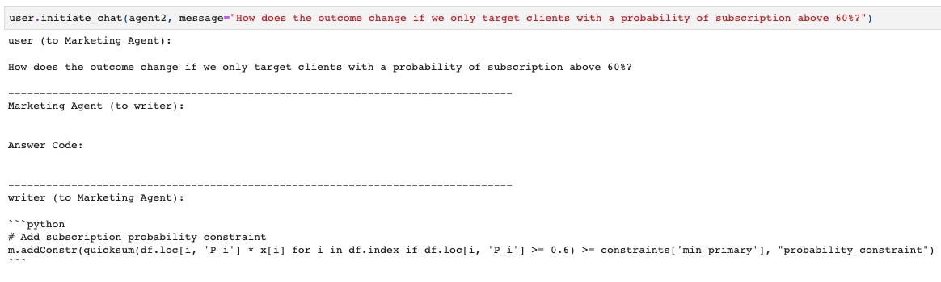

Solution count 3: 11327.8 10896.7 10846.5

--- HUMAN READABLE ANSWER ---

--------------------------------------------------------------------------------

writer (to Marketing Agent):

The code provided adds a new constraint to the optimization model where we are only targeting clients with a probability of subscription above 60%. The "min_primary" constraint makes sure we are still targeting at least 1000 clients.

The model's status of 1 indicates that it is loaded and a solution is available. This suggests that the adjustment has been successfully applied and optimization has been done.

However, without knowing the new objective value or solutions (xi values), we can't completely compare the new results with our original findings. If the new objective value is larger than the original one, this means our net profit increased by only targeting clients with over 60% subscription probability.

--------------------------------------------------------------------------------

**Question 5.How does the outcome change if we only target clients with a probability of subscription above 40%?**

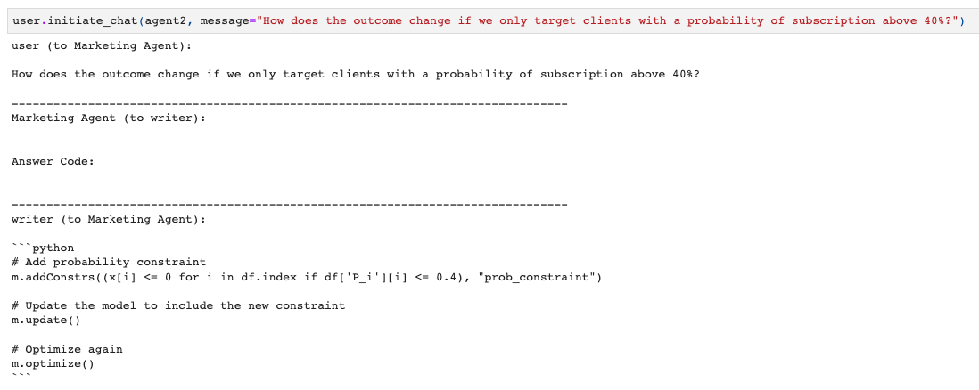

Solution count 3: 11327.8 10896.7 10846.5

--- HUMAN READABLE ANSWER ---

--------------------------------------------------------------------------------

writer (to Marketing Agent):

Sure. By applying the new constraint where we only target clients with a probability of subscription above 40%, the optimization is successful with a status code of 1.

However, it's important to note that this additional constraint could impact the total net profit and possibly reduce it. This would occur if you have clients with a subscription probability of under 40% who might still bring in net profit overall.

To know for sure, it would be beneficial to compare the new objective value (net profit) obtained after imposing this new constraint with the original objective value of 11327.79. If the new objective value is lower than the original one, it indicates that imposing such constraint leads to a reduction in net profit.

--------------------------------------------------------------------------------

Additionally, the bank wants to consider the overall subscription rate of contacted clients — that is, the number of subscribers over the total contacted clients, which is a key performance indicator (KPI) for the marketing campaign — in Model 2, the rate was over 40%. However, in Model 3, with a balanced consideration of education, it was less than 40%. The bank wants to ensure the rate to be greater than 40%. Question 6 is related to the overall subscription rate in Model 3.

After applying a constraint in Model 3 that the rate must exceed 40%, we found only a 0.1% decrease in the optimal value. This implies that Model 3 requires only a minor sacrifice in profit to ensure an adequate subscription rate among contacted clients. This again convinces us the efficiency of Model 3.

**Question 6.what if there is an additional constraint that the overall subscription rate among the selected clients should be over 40%?**

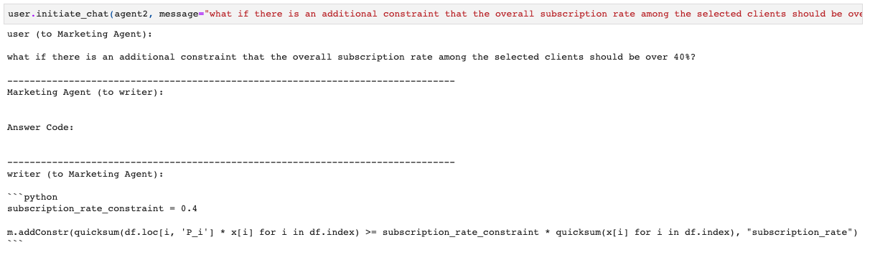

Solution count 3: 11327.8 10896.7 10846.5

--- HUMAN READABLE ANSWER ---

--------------------------------------------------------------------------------

writer (to Marketing Agent):

Sure. By applying the new constraint where we only target clients with a probability of subscription above 40%, the optimization is successful with a status code of 1.

However, it's important to note that this additional constraint could impact the total net profit and possibly reduce it. This would occur if you have clients with a subscription probability of under 40% who might still bring in net profit overall.

To know for sure, it would be beneficial to compare the new objective value (net profit) obtained after imposing this new constraint with the original objective value of 11327.79. If the new objective value is lower than the original one, it indicates that imposing such constraint leads to a reduction in net profit.

--------------------------------------------------------------------------------

## Part 3: The Parameters in the Objective Function of Model 3

We continue to consider the sensitivity analysis of the objective function in Model 3. The objective function of Model 3 has two parameters, namely profit per subscription and cost per call. The initial value is 10 and 2. Profit per subscription is the bank's estimate of profit for each successfully subscribed client.. Cost per call is our calculation of external costs, which may increase due to employee strikes to demand wage increases, or decrease due to the outsource the phone call business and reduce labor costs. These situations will all cause changes in external costs. Questions 7 to 10 are related to the parameters in the objective function in Model 3.

We changed profit per subscription by 10% upwards and downwards respectively, and changed cost per call by 20% upwards and downwards respectively, and found that they can have an impact of about 20% on our target equation.

**Question 7. What if profit per subscription increases by 10%?**

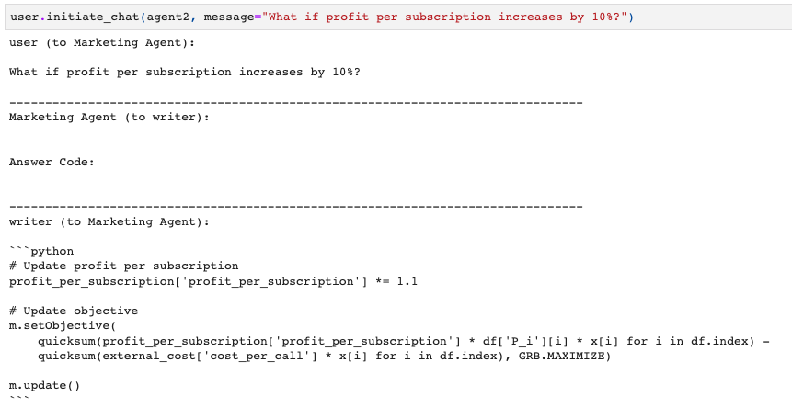

--- HUMAN READABLE ANSWER ---

--------------------------------------------------------------------------------

writer (to Marketing Agent):

Sure,

In the original scenario, the net profit from the marketing campaign was found to be approximately 11327.79.

If we increase the profit per subscription by 10% as per your request, the new net profit is approximately 13703.80.

The increased profit_per_subscription has led to an increase in the total net profit. Comparing the results, we can see that there was roughly a 21% increase in the net profit.

It is clear that an increase in subscription profit significantly impacts the overall profit of the marketing campaign.

--------------------------------------------------------------------------------

**Question 8. What if profit per subscription decreases by 10%?**

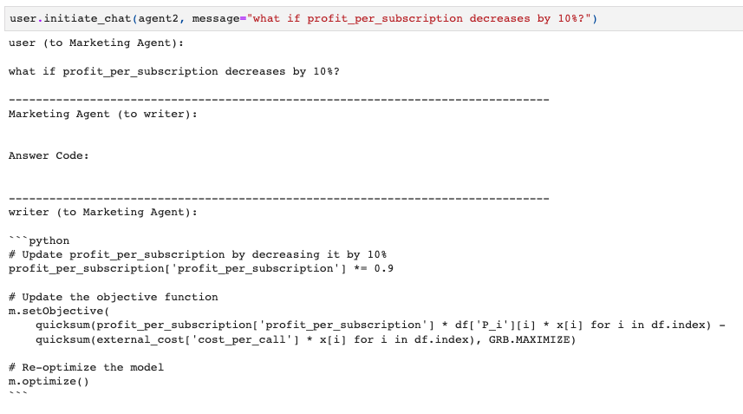

--- HUMAN READABLE ANSWER ---

--------------------------------------------------------------------------------

writer (to Marketing Agent):

Absolutely!

When we compared the new results with the original results, we found that the optimal value (maximized net profit) decreased from 11327.79 to 9071.54.

This decrease in profit is expected as we have reduced the profit per subscription by 10%. Now each successful call brings in less profit, reducing the overall profitability of the campaign, even if the same number of calls are successful. This highlights the importance of maintaining high profitability per subscription in your marketing campaign.

Therefore, a 10% decrease in profit per subscription led to a 20.1% decrease in overall net profit.

--------------------------------------------------------------------------------

**Question 9. What if cost per call increases by 20%, due to employees' strike to demand wage increases?**

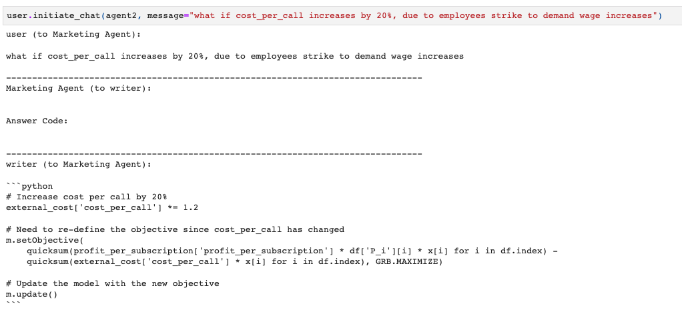

--- HUMAN READABLE ANSWER ---

--------------------------------------------------------------------------------

writer (to Marketing Agent):

Certainly! After adjusting the cost per call by 20% due to an employee strike, the optimal value, or maximized net profit, has been reduced to approximately $9173.18.

In comparison, the original net profit before adjusting for the strike was approximately $11327.79. Thus, after the adjustment, the net profit decreased by around $2154.61.

This means that an increase in operational costs, such as a 20% increase in the cost per call due to an employee strike, could significantly affect the profitability of the marketing campaign.

--------------------------------------------------------------------------------

**Question 10. What if cost per call decreases by 20%, for the bank to outsource the phone call business and reduce labor costs?**

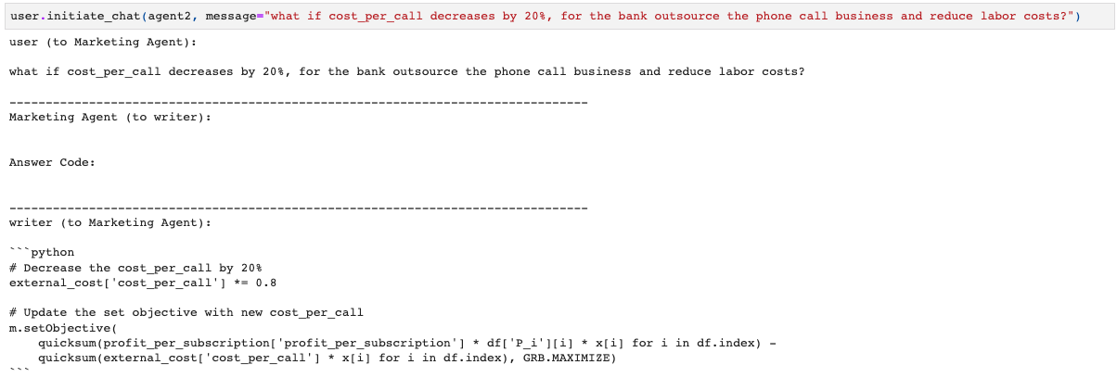

--- HUMAN READABLE ANSWER ---

--------------------------------------------------------------------------------

writer (to Marketing Agent):

Certainly. The updated objective function takes into account the decreased cost per call, which is now 20% less than before as the bank outsourced the phone call business and reduced labor costs. This results in a new optimized solution for the campaign.

By decreasing the cost_per_call by 20%, the optimized net profit increased significantly. Initially, the optimized net profit was $11,327.79. After taking into account the reduced cost of phone calls, the optimized net profit increased to $13,965.25.

The increase in the optimized net profit demonstrates that reducing operating costs, in this case via outsourcing, can significantly improve profits in a supply chain context, holding everything else constant.

--------------------------------------------------------------------------------

## Part 4: Challenges in OptiGuide

**Inconsistency.** First of all, inconsistency is manifested between the human readable answer and the actual code running results. For example, in Question 3, finding the best parameter combination problem, it can find the best optimal value, but provides wrong parameters in the first place. In addition, inconsistency manifests itself in the fact that when asking the same problem multiple times, it will give different results.

**Wording.** In the process of asking questions about it, wording is very important. First of all, we need to pay attention to the difference between human understanding and code language and only provide a code language. For example, when searching for the optimal solution in the range of 500 to 1500, the range (500, 1500) is a mathematical concept that humans can understand, but OptiGuide will comprehend it as a set, containing only two values ​​500 and 1500. In addition, if it is necessary to compare different models, OptiGuide will not do it automatically without very detailed code instructions and even enter the original results.

**Key takeaways.** Users cannot just look at the human readable answer, but need to look at the process of running the code, or take out the code and run it ourselves to verify the results. Users need to mind their wording, and provide as detailed instructions in the questions as possible.

# Appendix

See the attached the optiguide.ipynb and html file in the source code folder.

# 

# 

# 

# 

# 

# 

# 

# Reference

1. ChatGPT. OpenAI.
2. https://www.prosalesconnection.com/blog/how-many-cold-calls-per-hour-should-i-make#:~:text=This%20will%20allow%20a%20good,is%2010%20calls%20per%20hour
3. https://www.glassdoor.com/Salaries/lisbon-sales-representative-salary-SRCH_IL.0,6_IM1121_KO7,27.htm